PCA(Principal Covariance Analysis)

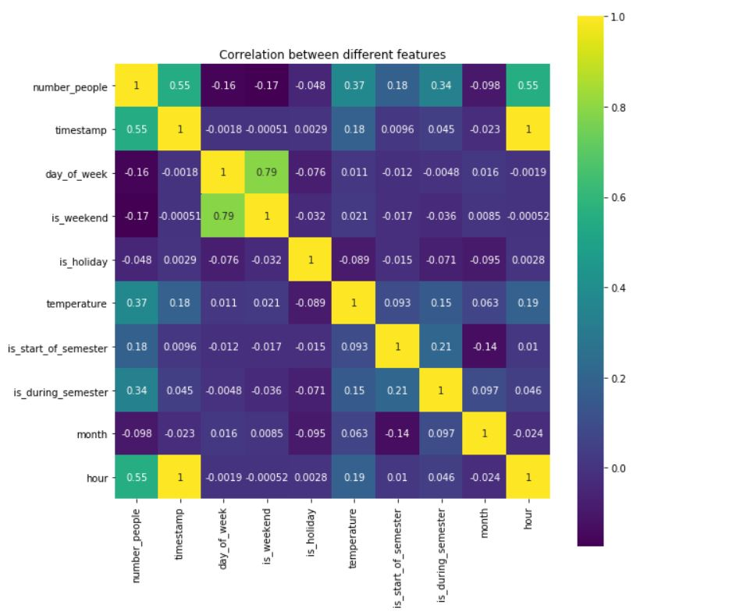

Fig:Correlation Matrix

The above correlation matrix is showing that the relation between the number of people and the features like timestamp, temperature, is during summer and hour. The feature month is negatively correlated to the number of people.